Mantid
PM report to Project Management Board
29th May 2015
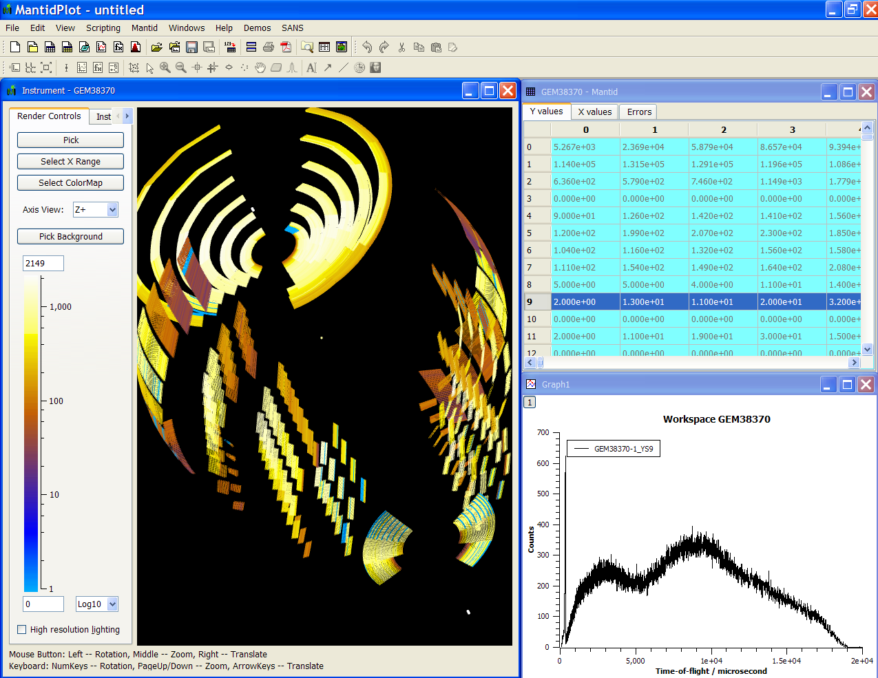
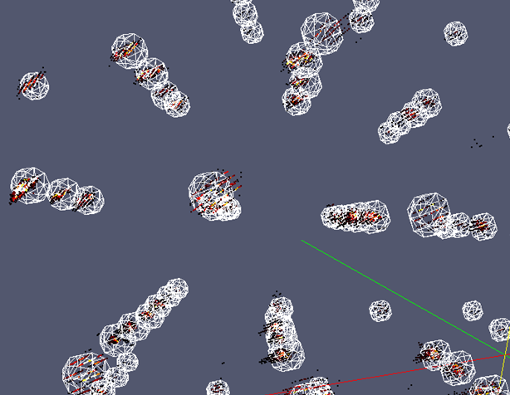
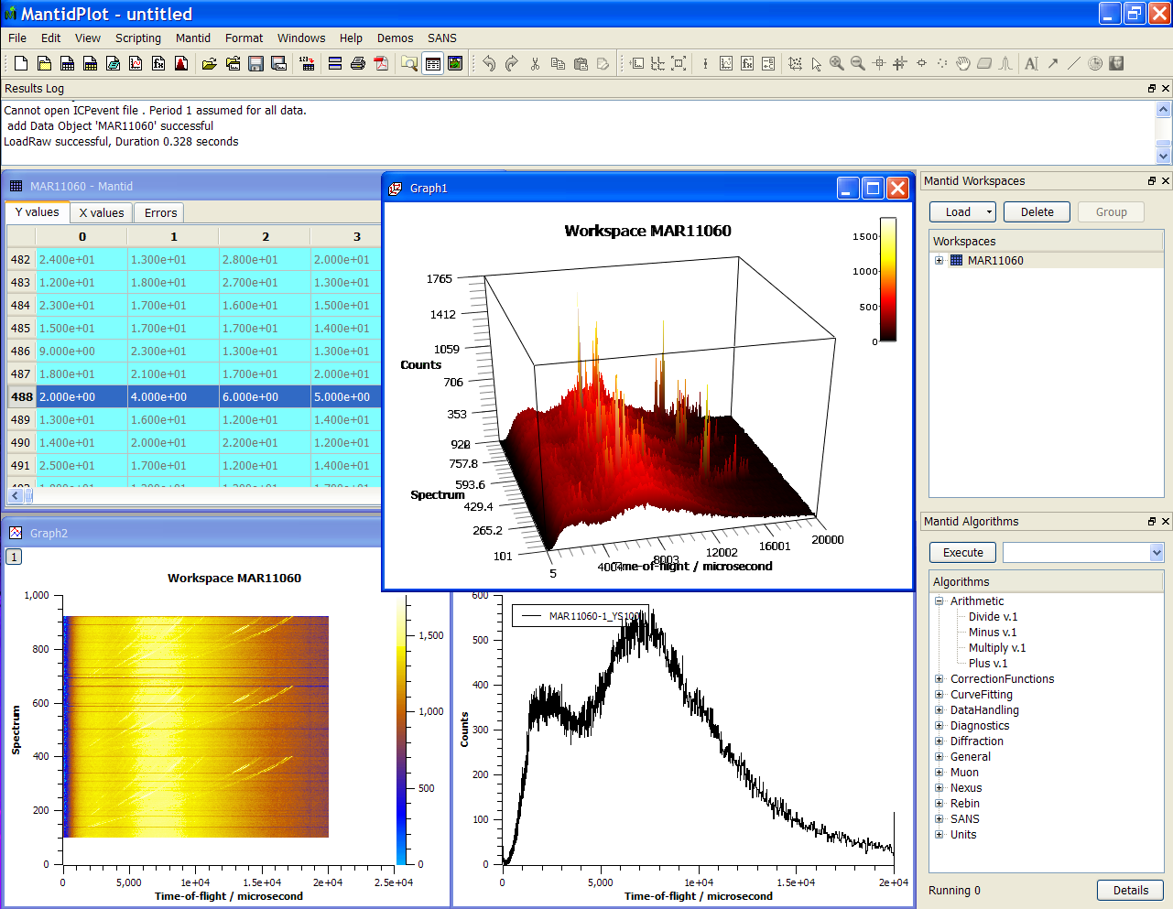
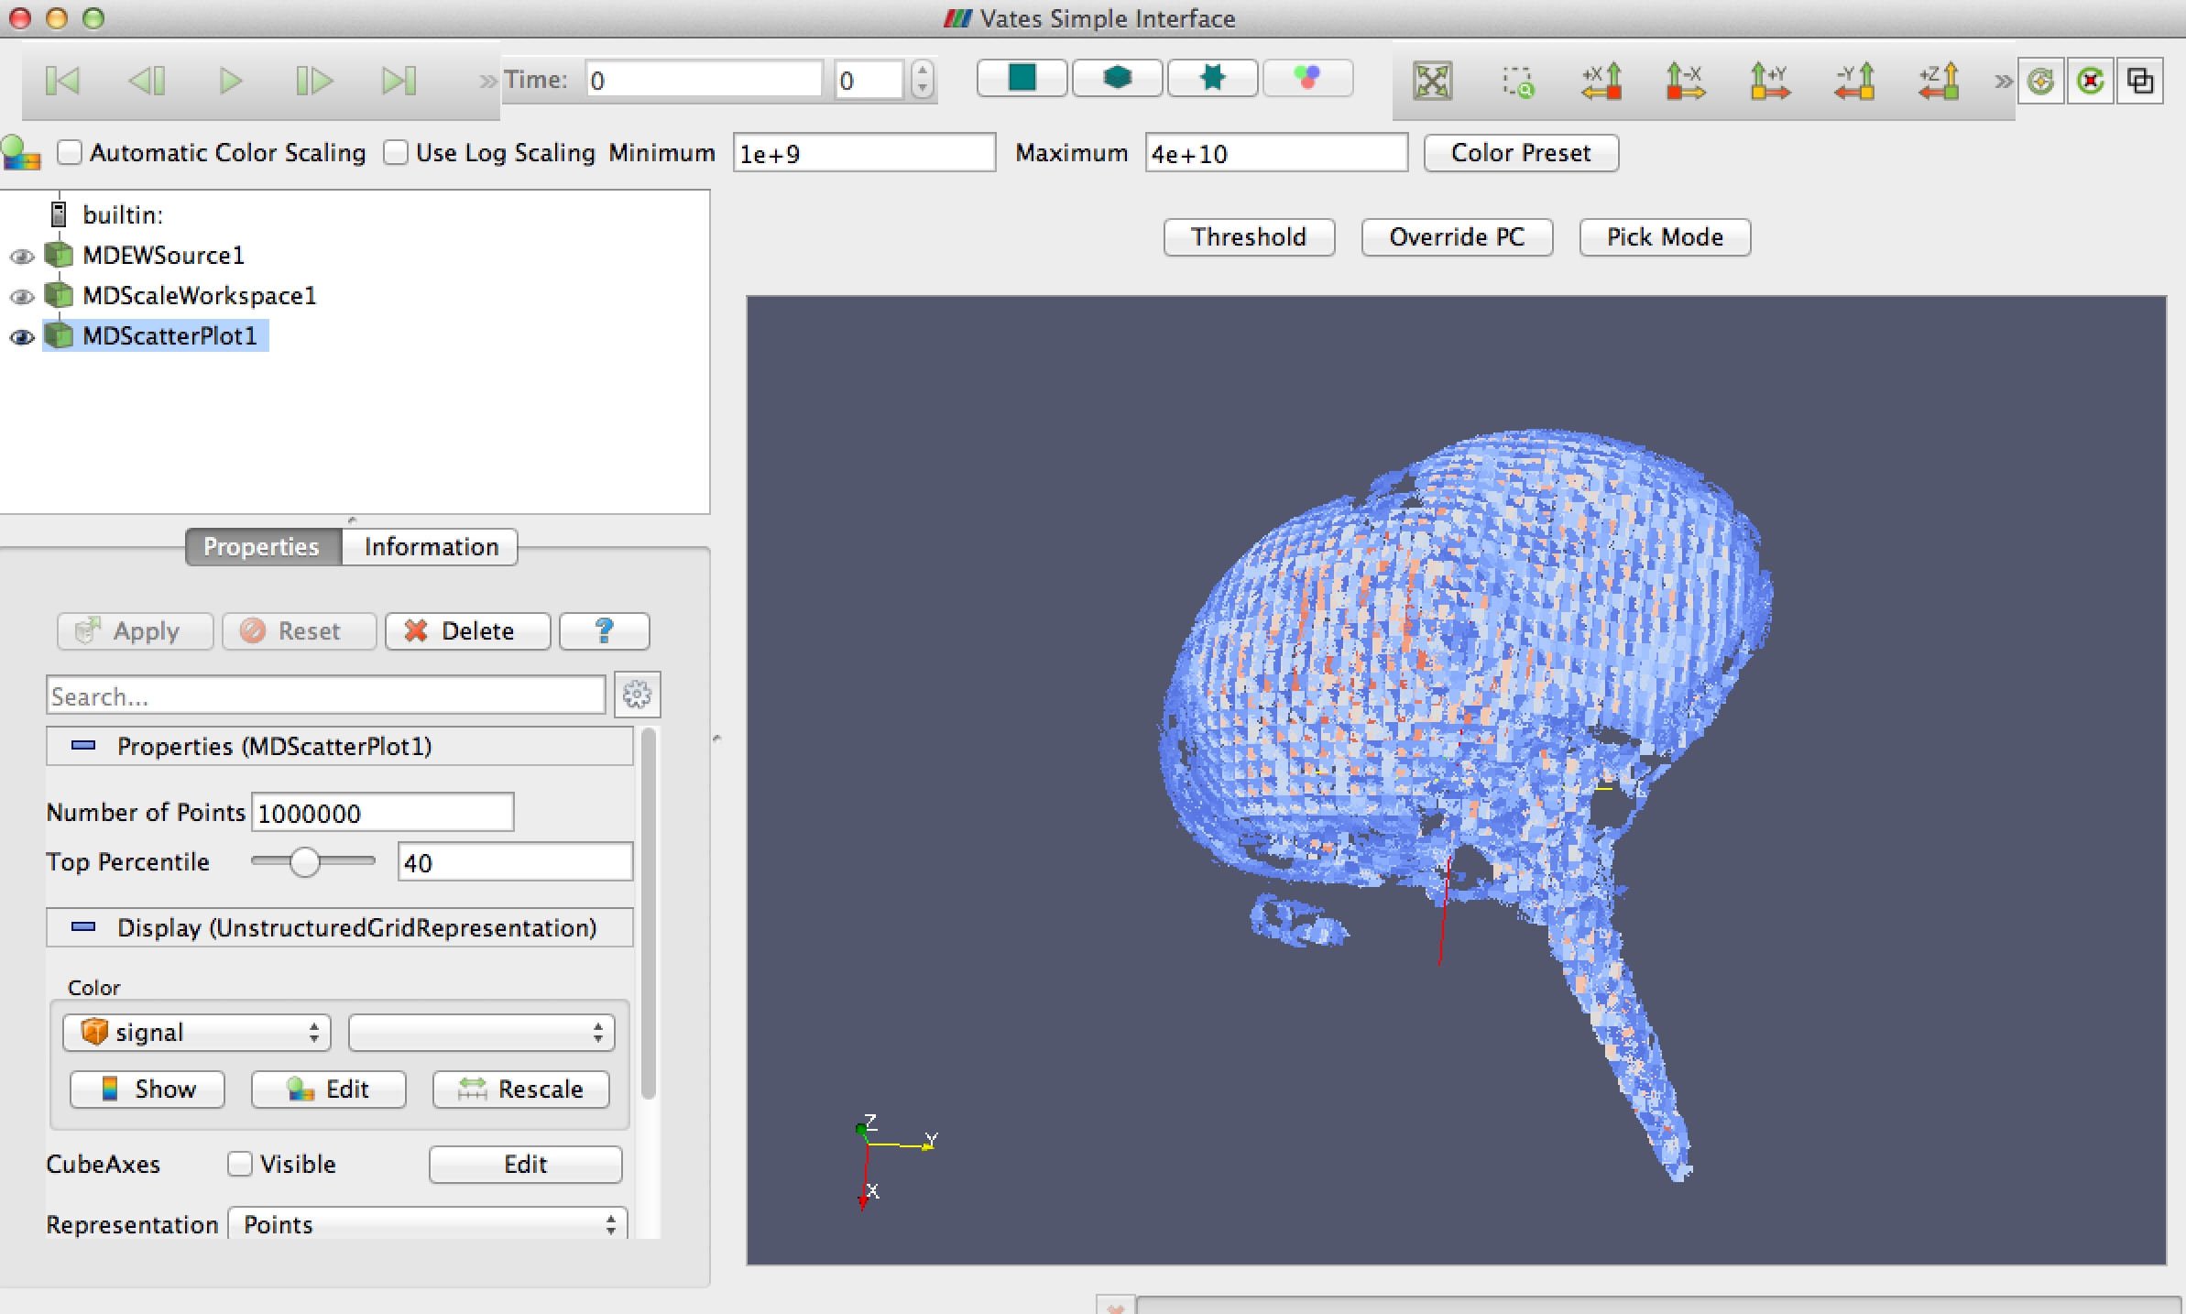
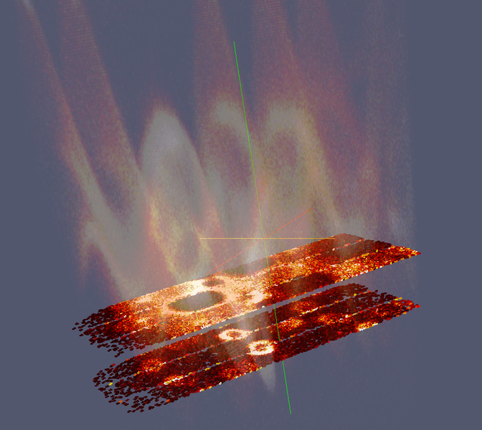
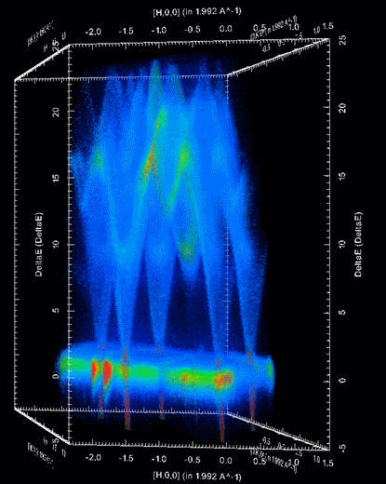

Document Control
This document is under document control. All members of the distribution list will receive updated copies whenever alterations are made. All other copies are uncontrolled.

Contributors
Name | Role | Company
Nicholas Draper | Author | Tessella

Document Approval
Name | Role | Company

Distribution
Name | Role | Company
Project Management Board Members | Recipient | STFC & ORNL
Mantid Project Repository | Filing | STFC & ORNL

Revision History
Author | Issue | Date | Description
Nicholas Draper | V1.R1.M0 | 28-May-2015 | 1st version written

References
Document | Ref | Date | Details and Version
Project Specification | [PS] |  | https://github.com/mantidproject/documents/blob/master/Project%20Management/ProjectSpecification.doc?raw=true
Stakeholder Plan | [SP] |  | https://github.com/mantidproject/documents/blob/master/Project%20Management/StakeholderPlan.doc?raw=true
Risk Register | [RR] |  | https://github.com/mantidproject/documents/blob/master/Project%20Management/RiskRegister.xls

Table of Contents
1 Introduction 3
2 Minutes of the previous meeting 4
3 Project Documentation 4
4 Project Status 4
5 Report from the TSC 5
6 Facilities strategies discussion following ISIS, SNS and ESS requirements reports 6
7 Usage of Mantid in various Environments 6
8 Interest from Other Facilities 7
9 Future Release Dates 7
10 Appendix A: Metrics 8

Introduction

Purpose of this Document
This report details the current state of the Mantid project and presents the agreed agenda for discussion. The project management board will use the information in this report as a basis for the meeting.

Scope of this Document
The scope of this document is limited to the Mantid project, both for progress up to the meeting of the Project management board, and plans for the future.

Context of this Issue
This is the fifteenth project management report to the Mantid project management board and will provide input to the meeting.

Minutes of the previous meeting
The minutes of the previous meeting are available here:
https://github.com/mantidproject/documents/blob/master/Project-Management/PMB/Minutes/PMBMinutes29thJan15?raw=true

Project Documentation
The project documentation is available through the links below. The documents have not been changed since the last PMB meeting.

Stakeholder Plan:
https://github.com/mantidproject/documents/blob/master/Project%20Management/Stakeholder Map.doc?raw=true
No changes this time

Risk Register:
https://github.com/mantidproject/documents/raw/master/Project-Management/RiskRegister.xls

The following changes have been made:
8 The risk has been reworded to cover changes to Mantid’s design rather than the original design itself, with design approval being the responsibility of the TSC.

New Risks being monitored:
34 Project cloud server fails to provide acceptable web performance / reliability
35 Jenkins build instances prove insufficient for the development.
We may want to consider asking the ESS to contribute two build servers (Windows + their environment)

Project Status

Development Progress
Since the last PMB meeting in January 2015 we created one release:
- Release 3.4 18-May-2015
Development continues at a good pace: see the project metrics in section 10.2.
We plan to migrate to github issues over the next release, we have identified the requirements for migration and reporting and progress has been made on both. Once these are completed we will plan the migration to occur such that it minimises the disruption to the development team.

Update on progress of SSC requirements

Completed in Release 3.4
id | summary | status | owner
#8916 | Improve vates visualisation defaults | closed | Nick Draper
#8926 | Multiple scattering sub project - outline document | closed | Nick Draper
#9274 | Improve Workflow Algorithm Documentation and Testing | closed | Nick Draper
#9290 | Investigate links to neutron training schools | closed | Nick Draper
#9292 | Absorption corrections for SANS | closed | Anders Markvardsen
#9293 | Basic SANS Model fitting in Mantid | closed | Anders Markvardsen
#9294 | Other SANS corrections | closed | Anders Markvardsen
#9299 | Visible Time Slicing | closed | Nick Draper
#9307 | Improvements to SliceViewer User expreience | closed | Nick Draper
#10110 | Improvements to VSI User Experience | closed | Peter Peterson
#10940 | Horace planner implementation | closed | Andrei Savici
#11229 | SCD Event Data Reduction needs to be able to output to a nexus file | closed | Vickie Lynch
#11244 | Output from SCDCalibratePanels is hard to work with | closed | Vickie Lynch
#11275 | Non-detector components in instrument geometry | closed | Nick Draper
#11279 | Roll out autoreduction at ISIS | closed | Anders Markvardsen
#11298 | Keep transmission data for SNS | closed | Mathieu Doucet
#11300 | Reuse saved configuration in GUI | closed | Mathieu Doucet
#11114 | Allow the splash screen to drop focus | closed | Nick Draper

Planned for Release 3.5
The headline tickets for R3.5 need some normalisation but the dynamic view of the plans is available here:
http://trac.mantidproject.org/mantid/roadmap
Or in the SSC Report: http://trac.mantidproject.org/mantid/wiki/SSC%20Report%202015

Report from the TSC
From Anders Markvardsen
https://raw.githubusercontent.com/mantidproject/documents/master/Project-Management/TechnicalSteeringCommittee/reports/TSC-PMB-report-2015-05-29.md

Facilities strategies discussion following ISIS, SNS and ESS requirements reports

ISIS Strategic Report
https://github.com/mantidproject/documents/raw/master/Project-Management/PMB/Mantid_sciencereport_ISIS.pdf

SSC Report
The SSC report is intended to allow discussion at a management level of the SSC requirements together with the strategic requirements raised by the contributing facilities.
At present it has been populated with the SSC requirements and the strategic requirements from ISIS, The strategic requirements from the SNS and ESS need to be added. It is also intended as a vehicle to communicate the development plan back to the SSC instrument scientists.

http://trac.mantidproject.org/mantid/wiki/SSC%20Report%202015

At present it is generated using trac, aspects of the formatting are likely to change as the management of requirements in the project is migrated to github issues.

Usage of Mantid in various Environments
We currently fully support the following environments:
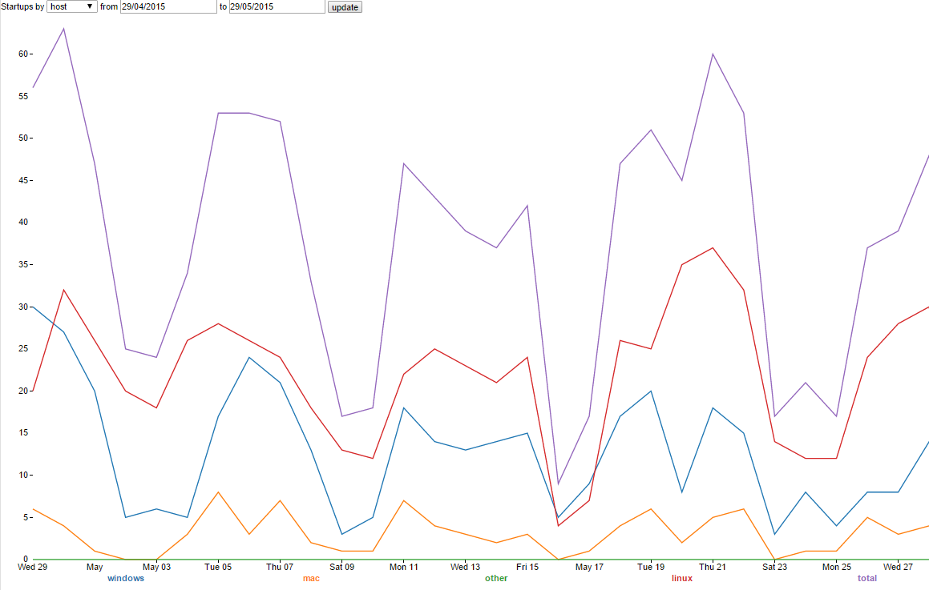
- RHEL 7 64bit
Total
Linux
Windows
Mac
- Windows 7 64 bit
- Ubuntu LTS 64 bit
- OS X 10.9 Mavericks
Limited Support:
Windows 8 64 bit

Current Usage:
http://reports.mantidproject.org/
Looking over the last month we have a similar number of active Linux and windows pcs running Mantid, between 20-40 machines running each on a normal weekday. The number of Macs is much lower with a peak of about 7 per day. Over the weekend Linux use remains high, windows use drops but remains significant. Mac users do not appear to work weekends.

Interest from Other Facilities

ILL
Mark Johnson and his colleagues attended the Mantid developer workshop, but returned to find that the Bastille funding has disappeared, and is unlikely to return before winter this year at best.
SINE2020 however has been funded, which provides 48 person months of effort of which a significant proportion is aimed at implementing Mantid support at the ILL. Without further support it would appear that this funding alone would only allow for a roll out of Mantid across a subset of instruments.

CSNS
Junrong Zhang and his colleagues from the CSNS attended the Mantid developer workshop. I have not had further contact since but it was clear that they had already made significant progress with Mantid. At this point I suspect there attention is on other areas of their scientific computing infrastructure.

Julich
Marina Ganeva and Celine Durniak attended the Mantid developer workshop and presented the work they are doing with Mantid.

Future Release Dates
The planned release dates for the future are:
- v3.5 5th October 2015
- v3.6 31st January 2016
This does not include patch releases.

Appendix A: Metrics

Project Metrics
The code metrics are independently generated and displayed here
http://www.openhub.net/p/Mantid/analyses/latest/languages_summary
Total Lines : | 2,775,501 |  | Code Lines : | 2,073,196 |  | Percent Code Lines : | 74.7%
Number of Languages : | 19 |  | Total Comment Lines : | 396,673 |  | Percent Comment Lines : | 14.3%
 |  |  | Total Blank Lines : | 305,632 |  | Percent Blank Lines : | 11.0%

In a Nutshell, Mantid...
- has had 45,064 commits made by 91 contributors representing 2,073,196 lines of code
- is mostly written in C++ with an average number of source code comments
- has a well established, mature codebase maintained by a very large development team with increasing Y-O-Y commits
- took an estimated 586 years of effort (COCOMO model) starting with its first commit in April, 2007 ending with its most recent commit about 21 hours ago

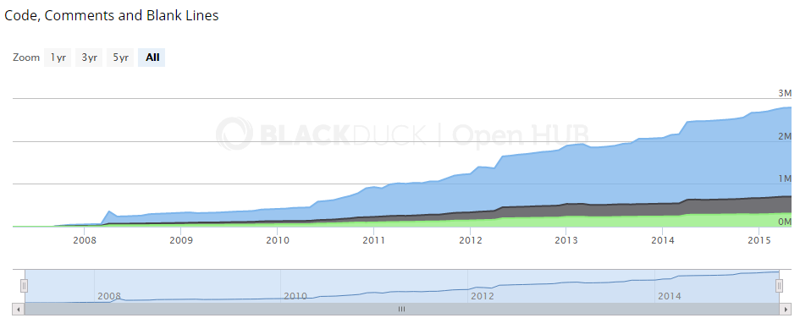

Ticket completion rate
Development on Mantid is performed in three -four month iterations, each of which ends with an official release of the software. Longer pieces of work sometimes have to span a development iteration in which case that piece of work appears as completed only in the iterations when it becomes available to the users.
The patch releases (2.x.x) are very much smaller and are used to solve issues that become apparent after the main release or release urgent improvements that have recently been added.

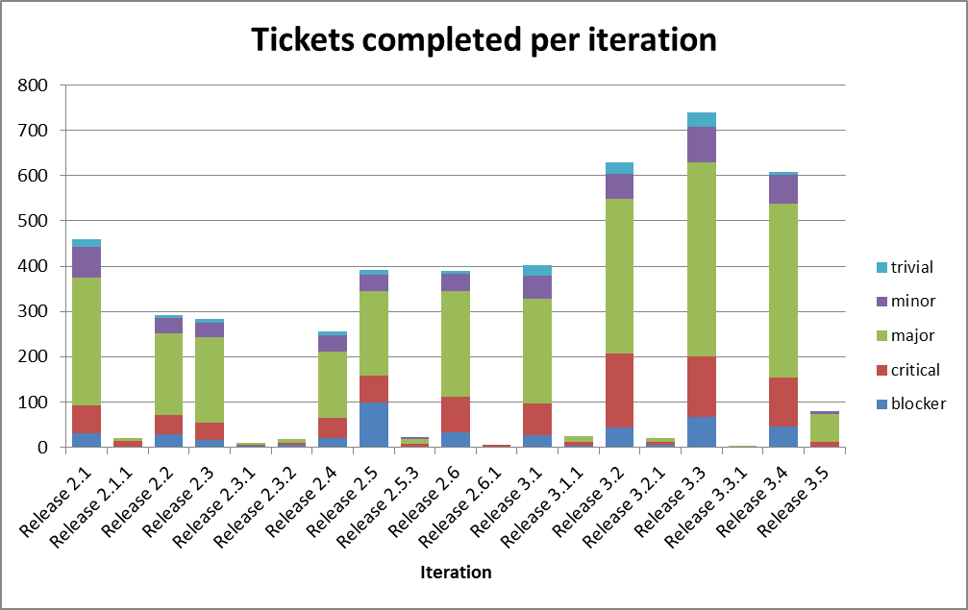
Release 3.5 has only just begun development.

